## **Learning by guessing**

Can we try to estimate w,b by using some guess work?

1. Steps:
   1. **Initialise:** w,b to 0
   2. **Iterate over Data:** guess_and_update(xi)
      1. w = w + 𝚫w
      2. b = b + 𝚫b
      3. Here, 𝚫w and 𝚫b are the amounts we change w and b, by pure guess-work. We need to design a function to replace the guess-work.
   3. **Till satisfied**
2. Consider the following dataset

|  |  |
| --- | --- |
| **I/P** | **O/P** |
| 2 | 0.047 |
| 3 | 0.268 |
| 4 | 0.73 |
| 5 | 0.952 |
| 8 | 0.999 |

1. Manually change the slope w and the midpoint b till it looks to fit the data, then perform fine-tuning to match the training examples as closely as possible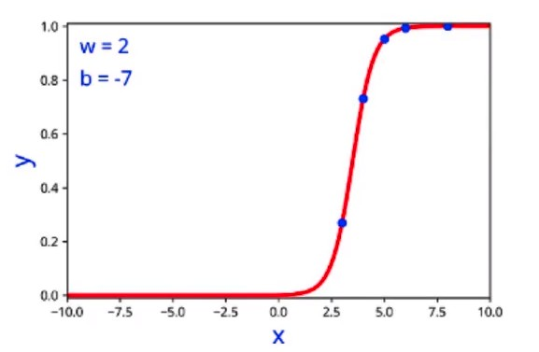
2. We have guessed, by trial and error and found that w=2 and b=-7 fits the training data best.
3. This is only possible in lower dimensions, 1D or 2D, and becomes much harder as more features are involved.